**Week – 6**

**React**

1. Create a new react application using *create-react-app* tool with the name as “blogapp”
2. Open the application using VS Code
3. Create a new file named as **Post.js** in **src folder** with following properties

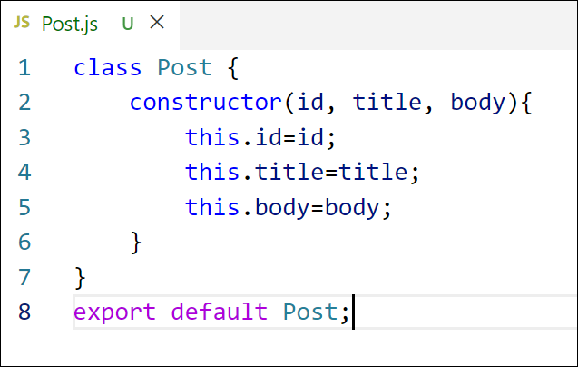

*Figure 2: Post class*

1. Create a new class based component named as **Posts** inside **Posts.js** file

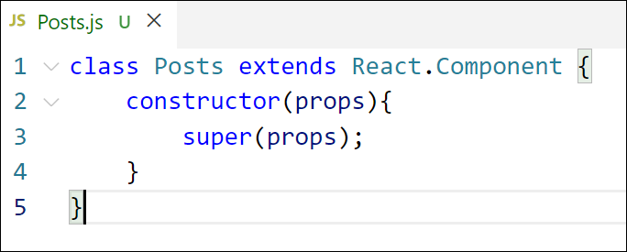

*Figure 3: Posts Component*

1. Initialize the component with a list of Post in state of the component using the constructor
2. Create a new method in component with the name as **loadPosts()** which will be responsible for using Fetch API and assign it to the component state created earlier. To get the posts use the url (<https://jsonplaceholder.typicode.com/posts>)

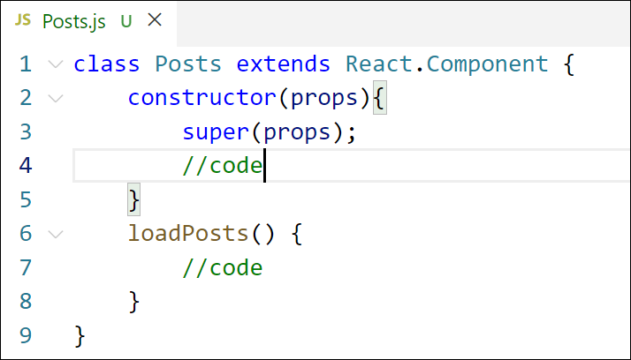

*Figure 4: loadPosts() method*

1. Implement the **componentDidMount()** hook to make calls to **loadPosts()** which will fetch the posts

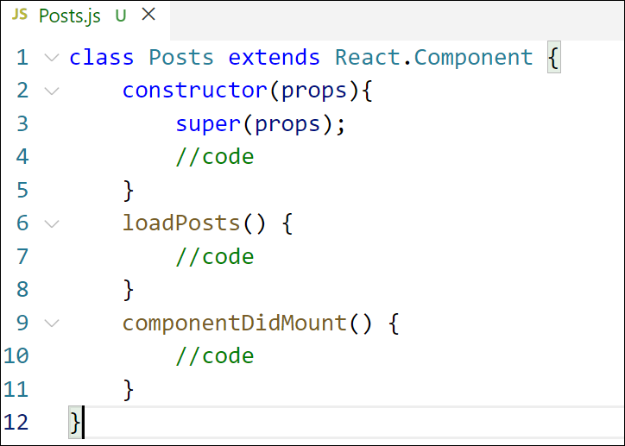

*Figure 5: componentDidMount() hook*

1. Implement the **render()** which will display the title and post of posts in html page using heading and paragraphs respectively.

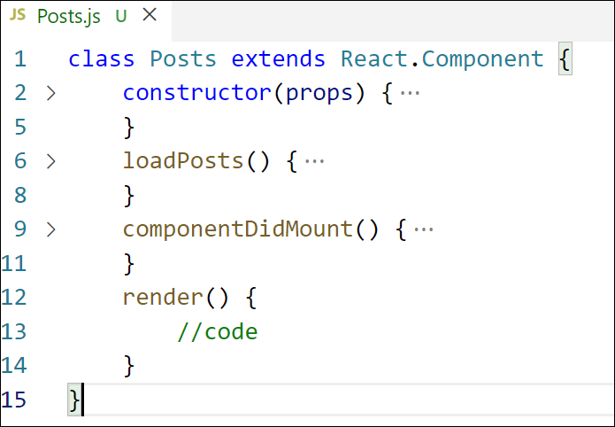

*Figure 6: render() method*

1. Define a **componentDidCatch()** method which will be responsible for displaying any error happing in the component as alert messages.

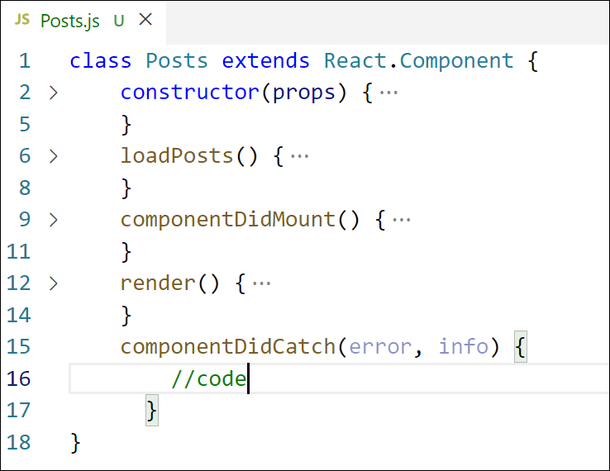

*Figure 7: componentDidCatch() hook*

1. Add the Posts component to App component.
2. Build and Run the application using *npm start* command.

**IMPLEMENTATION :**

**Create the React App**

npx create-react-app blogapp

cd blogapp

code .

**src/Post.js**

import React from 'react';

class Post extends React.Component {

render() {

const { title, body } = this.props;

return (

<div style={{ marginBottom: '20px' }}>

<strong style={{ fontSize: '16px', display: 'block', marginBottom: '5px' }}>

{title}

</strong>

<p style={{ margin: 0 }}>{body}</p>

</div>

);

}

}

export default Post;

**src/Posts.js**

. import React from 'react';

import Post from './Post';

class Posts extends React.Component {

constructor(props) {

super(props);

this.state = {

posts: [],

};

}

loadPosts = () => {

fetch('https://jsonplaceholder.typicode.com/posts')

.then((res) => res.json())

.then((data) => this.setState({ posts: data }))

.catch((error) => {

alert('Error fetching posts: ' + error.message);

});

};

componentDidMount() {

this.loadPosts();

}

componentDidCatch(error, info) {

alert('An error occurred: ' + error.message);

}

render() {

return (

<div style={{ padding: '30px', textAlign: 'left', maxWidth: '900px', margin: '0 auto' }}>

<h2 style={{ marginBottom: '20px' }}>Posts</h2>

{this.state.posts.map((post) => (

<Post key={post.id} title={post.title} body={post.body} />

))}

</div>

);

}

}

export default Posts;

**src/App.js**

import React from 'react';

import './App.css';

import Posts from './Posts';

function App() {

return (

<div className="App">

<Posts />

</div>

);

}

export default App;

**Run the React App**

npm start

**Open in Browser**

http://localhost:3000

**OUTPUT :**

